Asia-China-Coin-3-Spade-Flat Handle-Arch Foot-H 3.41-R 2

FD291

length 5.7CM/2.24Inches, width 3.1CM/1.22Inches

垣釿桥足布."垣釿","YuanJin"Bridge-foot Spade-shape Coin."垣"place of Wei Nation.Now it is the SouthWest of Qu Country,ShanXi Province.."釿"JIN,Ancient metals weight,as well as currency.This one was made in the WEI Nation,while used in the 3JIN and 2Zhou area.

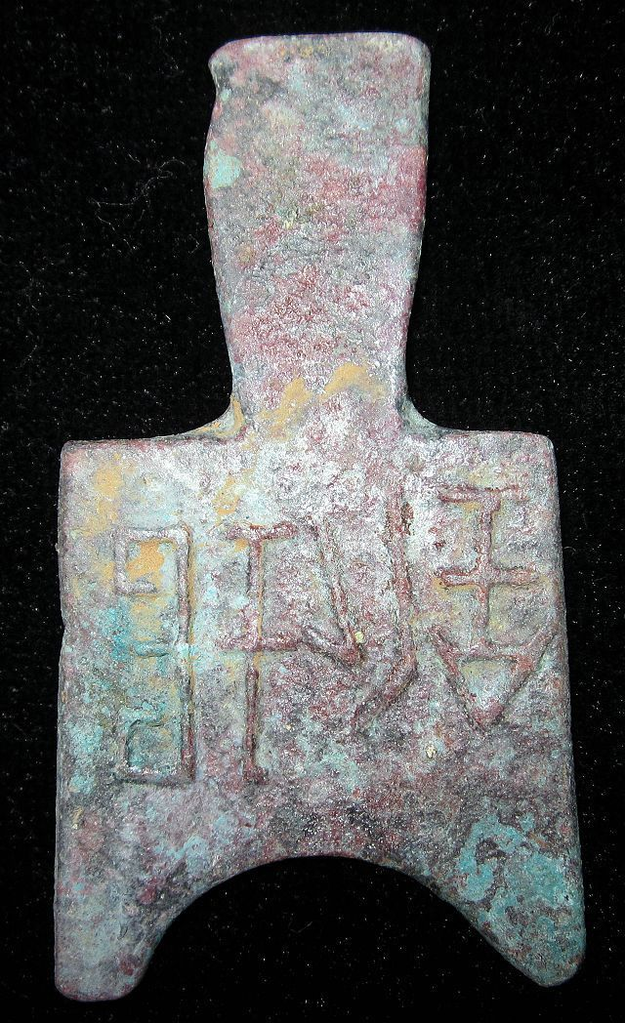

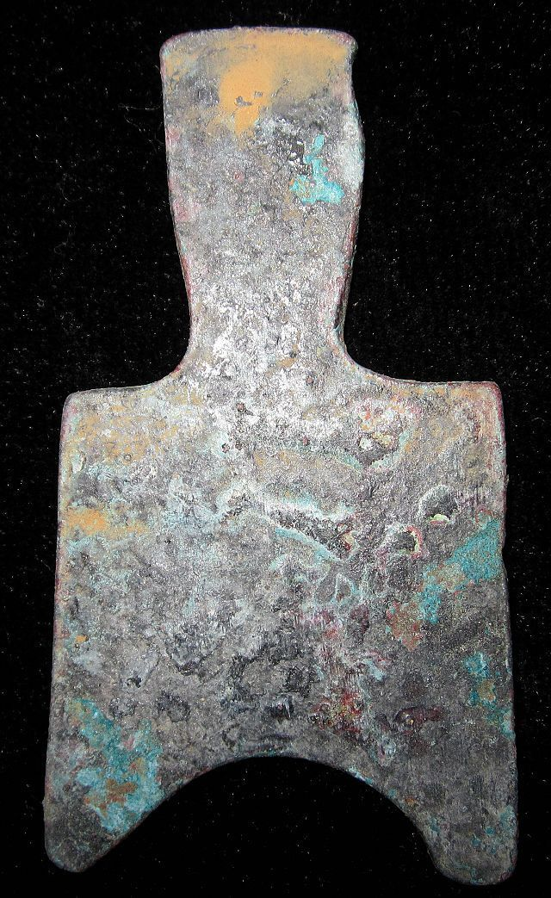

|  |  |  |  |  |  |  |  |  |  |  |  |  |  |  |  |  |  |  |  |  |  |  |  |  |  |  |  |  |
| --- | --- | --- | --- | --- | --- | --- | --- | --- | --- | --- | --- | --- | --- | --- | --- | --- | --- | --- | --- | --- | --- | --- | --- | --- | --- | --- | --- | --- |
| |  |  |  |  |  |  | | --- | --- | --- | --- | --- | --- | | |  |  |  |  |  | | --- | --- | --- | --- | --- | | • | • [Back to previous page](javascript:history.go(-1)) | • |Listed in category: | |  | | --- | | [Coins & Paper Money](http://www.ebay.com/sch/Coins-Paper-Money-/11116/i.html)>[Coins: Ancient](http://www.ebay.com/sch/Coins-Ancient-/4733/i.html)>[Other](http://www.ebay.com/sch/Other-/532/i.html) | | |  You won this auction. | [View order details](http://payments.ebay.com/ws/eBayISAPI.dll?ViewPaymentStatus&transid=0&ssPageName=STRK:MESO:VPS&itemId=251416092743)  |  |  |  | | --- | --- | --- | | Details about  VINTAGE WarringStatesPeriod CITY MINT CURRENCY MONEY BRONZE SPADESHAPE COIN垣釿桥足布 [See original listing](http://www.ebay.com/itm/VINTAGE-WarringStatesPeriod-CITY-MINT-CURRENCY-MONEY-BRONZE-SPADESHAPE-COIN-/251416092743?nma=true&si=5L4Tlo08dyY9pQflhUEb6fWvMTI%253D&orig_cvip=true&rt=nc&_trksid=p2047675.l2557) | | | | |  |  | | --- | --- | | |  | | --- | |  | | |  |  | |  |  | | Item condition:  --not specified  “Rust on the body,Museum quality” |  | | Ended:  Jan 08, 2014 21:21:10 PST |  | | Winning bid:  US $78.00  [ [12 bids](http://offer.ebay.com/ws/eBayISAPI.dll?ViewBids&_trksid=p2047675.l2565&rt=nc&item=251416092743) ] |  | | Shipping:  $10.00 Economy Shipping from outside US |  | | Item location:  GuangZhou, China |  | | Seller:  [bcculture](http://myworld.ebay.com/bcculture?_trksid=p2047675.l2559) ([84](http://feedback.ebay.com/ws/eBayISAPI.dll?ViewFeedback&userid=bcculture&iid=251416092743&ssPageName=VIP:feedback&ftab=FeedbackAsSeller&rt=nc&_trksid=p2047675.l2560) )  |  [Seller's other items](http://www.ebay.com/sch/bcculture/m.html?item=251416092743&rt=nc&_trksid=p2047675.l2562) |  | |